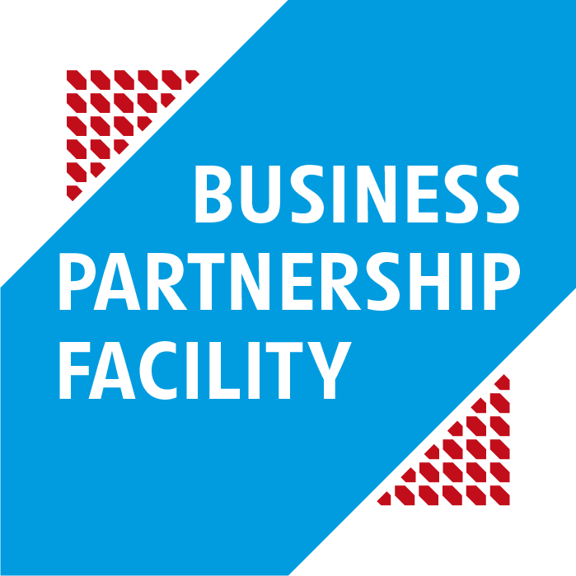 | BPF 2021  Application form

This application form must be submitted electronically to the following email address:
bpf@luxdev.lu

Candidates may attach any document they consider appropriate however this form must be duly completed, otherwise the application will be rejected.
More information on the required data to be provided in the application form can be found in the “practical guide” which can be downloaded on the BPF website (http://bpf.lu/guide-pratique).
Throughout this application form, the term “lead partner” refers to the Luxembourgish or European private company representing the candidate and which ensures the coordination task. Public or private partners from the developing countries where the project will be implemented are called “local partners”. Other potential partners, private or public, Luxembourgish or European, are called “associated partners”. Finally, “candidate” refers collectively to the lead partner, the local and all possible associated partners.

- CANDIDATE IDENTITY
  - Identity of the lead partner
Company name
Head Office Address
[No, street, postcode, town]
Business sector | CleanTech, eco-innovation and circular economy ☐ |  | Fintech ☐
 | HeathTech ☐ |  | Information and Communication Technologies (ICT) ☐
 | Mobility and logistics ☐ |  | Space ☐
 | Others ☐
Description of the company activities | Please briefly describe the main activities of your company. Max ¼ page.  Specify if the company is part of a group.  Candidates are invited to attach the latest annual report of the company
Number of staff and male / female distribution
Company creation date
Turnover (EUR) of the company  Candidates are invited to attach last financial statements of the company | 2018 | 2019 |  | 2020
Previous experiences in developing countries | Please describe previous or current experiences the company has(d) working in or with developing countries
Responsible Business Conduct | In order to receive financial support from the BPF facility, private companies have to demonstrate that they integrate social, environmental and good governance concerns into their strategy and economic development, such as compliance with the UN guiding principles on Human rights, decent working conditions, rules of good governance and the standards applicable to the respective sectors.  Candidates are invited to attach any additional documentation they deem relevant on the subject (certification, CSR action plan, etc.)  Max ¼ page
Administrative details
Trade register number
VAT number
Share capital
Website

  - Contact person
Name
Position
Phone number
Email address
  - Identity of the associated partners (if applicable)
Associated partner 1
Company name and address
Business sector(s)
Creation date
Turnover (EUR) of the associated partner  Candidates are invited to attach last financial statements of the company | 2018 | 2019 | 2020
Description of the company activities | Please briefly describe the main activities of your company
Number of staff and male / female distribution
Previous experiences in developing countries | Please describe previous or current experiences the company had with developing countries
Responsible Business Conduct | In order to receive financial support from the BPF facility, private companies have to demonstrate that they integrate social, environmental and good governance concerns into their strategy and economic development, such as compliance with the UN guiding principles on Human rights, decent working conditions, rules of good governance and the standards applicable to the respective sectors.  Max ¼ page
Each associated partner must complete the table above
- PROJECT OUTLINE (Concept note)
  - Target countries
Please name the country(ies) where the candidate plans to implement the project

  - Business sector(s) targeted by the project
CleanTech, eco-innovation and circular economy ☐ | Fintech ☐ | HeathTech ☐
Information and Communication Technologies (ICT) ☐ | Mobility and logistics ☐ | Space ☐
Fight against the COVID-19 pandemic ☐
  - Project description (maximum 2 pages)
Describe the project in maximum 2 pages. The candidate may describe the market targeted by the project, the planned investments, the expected results, the target audience, the activities to be undertaken and the project’s maturity stage. The innovative aspect of the project will also be considered.

  - Expected impact(s) of the project (maximum 1 page)
Social and environmental impacts and financial viability are key for a successful and sustainable partnership. The support granted by the BPF facility should therefore contribute to the achievement of sustainable development goals such as job creation, green and inclusive growth and more broadly, poverty reduction.
Please describe expected project results in terms of job creation, technology and/or knowledge transfer, impact on economic development of the target country(ies), social and environmental impacts including Human rights respect, replication / multiplication, etc…

  - Local partner(s) envisaged in the target country(ies)
The candidate must specify whether the local partner (s) are already identified at this stage. Candidate must also complete all or part of the table below (one table per partner).
The candidate can also consult the BPF website (https://bpf.lu/en/developing-countries-partners) to find local partners.
Name of the local partner
Head Office Address
[No, street, postcode, town]
Kind of partner | Private sector ☐ | Research Institute ☐
 | Civil society ☐ | Other ☐
 | Public sector ☐
Description of the activities | Please briefly describe the nature of the activities of the local partner
Description of the partnership | Please briefly describe the state of the partnership
Responsible Business Conduct | Please briefly describe if and how the local partner private integrates social, environmental and good governance concerns into their strategy and economic development, such as compliance with the UN guiding principles on Human rights, decent working conditions, rules of good governance and the standards applicable to the respective sectors.
  - Project budget
Total indicative project budget (EUR)
Amount requested through co-financing (indicative) – maximum 200.000 EUR and maximum 50% of the budget

As a reminder, the candidate has to co-finance the project from its own funds and not from a grant obtained from another public actor. Loans from financial institutions can be considered as part of the co-financing brought by the candidate.
Pursuant to the regulations on the “de minimis” aid, particular attention must be paid to the compliance with the public aid ceiling which may not exceed 200.000 EUR over the last two fiscal years and the current fiscal year all aids combined. Please note that as this ceiling is reduced to 100 000 EUR for companies working in the field of road transport, thus maximum BPF co-financing is limited to 100 000 EUR.
In this context, the leader partner and its possible associated Luxembourgish and/or European partner are required to complete the table below. For more details on “de minimis” aids, please refer to the “guide pratique”, chapter 1.4.
Recipient company |  | Denomination of the aid | Amount received | Source of the aid | Date of granting

- STATEMENT OF GOOD STANDING

To the attention of: LuxDev, MAE/014 project
Object: Call for projects - BPF Facility 2021
I (we) the undersigned ………………………………………………………………………………… (names), in my (our)capacity of …………………………………………………………………………… (positions), for the company .……………………………………………………………………….....(name of the entity) established in ……………………………………….... (place of registration),
Certify that the entity I (we) represent:
- is not bankrupt, insolvent, is not being wound up, has not ceased operations, is not having its affairs administered by the courts, has not entered into an arrangement with creditors and is not in any analogous situation arising from a similar procedure provided for in national legislation or regulations;
- is not the subject of proceedings for a declaration of bankruptcy, of administration by the court, of winding up, of an arrangement with creditors or of any other proceedings of that nature in national legislation and regulations;
- has not been convicted of an offence concerning its professional conduct by a judgment which has the force of res judicata;
- has not been convicted of an offence concerning environmental crimes and acts against environmental regulations and legislations (regardless of the country) by a judgment which has the force of res judicata;
- complies with the United Nations Guiding Principles on Business and Human Rights and with the OECD Guiding Principles on Human rights (chapter IV) for itself and the whole value chain of which it is part;
- has fulfilled its obligations relating to the payment of social security contributions in accordance with the legal provisions of the country in which it is established or those of the country of the Contracting Authority;
- has fulfilled its obligations relating to the payment of taxes in accordance with the legal provisions of the country in which it is established or those of the country of the Contracting Authority;
- has not been guilty of serious misrepresentation in supplying the information required for its participation in procedures pertaining to call for tender and call for proposals;
- has not been in breach of its contractual obligations in the performance of contracts with the same Contracting Authority and/or other contracts financed by the Donor in the country of the Contracting Authority and/or any other country;
- is not prohibited from participating in tenders with other donors or excluded from public procurement in the country of the Contracting Authority and/or any other country;
- has not been convicted by a final judgement or final administrative decision for behaviour related to a criminal organisation;
- has not been convicted by a final judgement or final administrative decision for setting up an entity with the intention of evading tax, social security or other legal obligations applicable under the legal provisions of the country where it is established or those of the country of the Contracting Authority;
- is in compliance with the regulations on the “de minimis” aid;
- and declares to have read and to accept all the conditions of the BPF, especially the co-financing for a minimum of 50% through its own funds.
I am (we are) aware that Lux-Development is entitled to request, prior to the award of the contract, proof that the company I (we) represent is not in any of the situations referred to above.
Done in ………………..……. on ………………………… 202X
For the Candidate
Signature and stamp
NB : If the signatory of this statement of good standing is in any of the above-mentioned situations of exclusion, he must indicate the corrective measures he has taken to rectify them in order to demonstrate his reliability. A case-by-case analysis will be carried out by the evaluation committee to determine whether it is legitimate to continue the procedure with this tenderer.

- JOINT COMMITMENT

Object: Call for projects - BPF Facility 2021

The entities listed below jointly and severally commit themselves as candidate for the above-mentioned call for projects. In case their application is retained, those entities declare to intend to submit a collective detailed proposal that will jointly and severally commit them.

Entity’s name and address: | Signature:

The lead partner is:
………………………………………………………………………..

Done in ………………..……. on …………………… 2021

Signature of the lead partner

Signature of the other partners (local and, where applicable, associated)

